**Green Society Public School**

**D- 20**

**Ratnanagar-7, Sauraha, Chitwan**

**First Terminal Examination-2082**

**Class: Three Time: - 2 hrs. F.M.: 50**

**Sub: Maths**

|  |
| --- |
| **Name: Roll No.: Sec.:** |
| **­­­­­­­­­­­­ ________________ ______________ OBT.MARKS:**  **INVIGILATOR EXAMINER** |

**Group-A [10×1=10]**

1. **Choose the correct answer.**
2. **The Roman Numeral for 50 is:**

i. V ii. L iii. C

1. **How many zeros are there in ten thousand?**

i.5 ii. 4 iii. 3

1. **In Devanagari numeral ,44 is written as:**

i. २४ ii.४४ iii. ५४

1. **The Hindu Arabic numeral for ८६ is**

i. 86 ii. 76 iii. 96

1. **The standard form of 2000+90 is**

i. 2090 ii. 2009 iii. 2900

1. **How many angles are there in a circle?**

i. 1 iii. 0 iii. 2

1. **Which one is odd number?**

i. 2450 ii. 2569 iii. 5566

1. **Which one is even number?**

i. 61 ii. 72 iii. 87

1. **Ascending order means**

i. small to small ii. big to small iii. small to big

1. **How many angles are there in a rectangle?**

i. 2 ii. 3 ii. 4

**Group-B [12×2=24]**

**1) What comes in between?**

१४३१ १४३३

७२०८ ७२१०

९४२४ ९४२६

७७२८ ७७३०

**2) Identify the shapes of the following.**

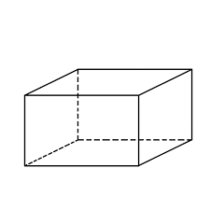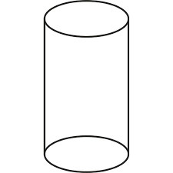



1. **Arrange the following Devanagari numbers in ascending and descending order.**

६४२९, ३०७२, ४१३८, ७९४३

Ascending order: ________________________________________________

Descending order: _________________________________________________

**4) Write the Roman Numerals for the following.**

16 = _______ 64= _________

48= ________ 95 = _________

**5) Complete the following Roman numerals.**

42= _______ LII 94_______ CIV

87= _______ XXXVII. 51= _______ I

**6) Compare the numbers using the signs (>, <, =).**

XV XIV LX XL



LXX 70 XLV 65

**7) What comes after?**

1890__________ 8973___________

8072__________ 8017___________

**8) Write odd and even for the following.**

5007=__________ 4868=_________

4692=__________ 1500=_________

**9) Write the names of the following.**

S

Angles=______or______

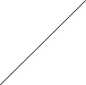

Arms=______and_______

T

U

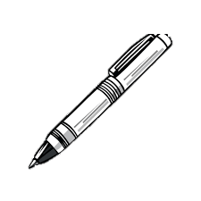**10) Write down the length of the following objects.**

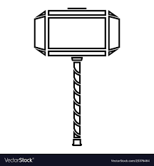

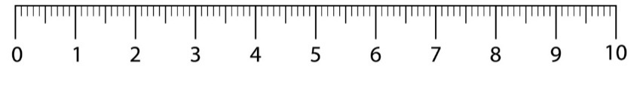

cm

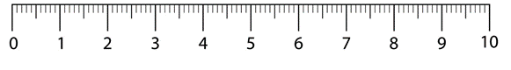

**11) Write the numerals for the following.**

a. Two thousand sixty-seven =_______________

b. Nine thousand and six hundred =____________

1. **Add horizontally.**

a.3624+8274=__________ b.4321+4978=__________

**Group-C (4×4=16)**

**1) Write the given Devanagari Numerals in word.**

६४० = ________________________________________________________________

४२९= ________________________________________________________________

२२०४=________________________________________________________________

९९९०= _______________________________________________________________

**2) Expand the following.**

6984=_______________________________________________________________

5270=_______________________________________________________________

3805=_______________________________________________________________

1001=_______________________________________________________________

**3) Add the following.**

**9 3 5 6 2 9 5 4**

** + 8 5 5 9 + 6 8 3 6**

**4) Name all the sides and angles of the triangle given below.**

R

Name= __________

Sides= _______, ______ and ______

Q

Angles= _______, ______ and ______

P

**THE END**